Award-winning Canadian children’s book author, Lana Button is presenting at our school! If you would like a personalized copy of any of Lana’s books, please return this form with payment, to your teacher by ____________. For more information on Lana Button and her books, visit www.lanabutton.com
Name |  |  | Teacher  Grade
QTY | Book Title |  |  |  | Unit Price | Total Price
 | 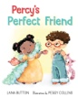 Percy’s Pefect Friend *NEW |  |  |  | $22.00
 | 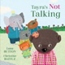 Tayra’s Not Talking |  |  |  | $22.00
 | 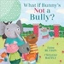 What if Bunny’s Not a Bully? |  |  |  | $20.00
 | 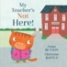 My Teacher’s Not Here! |  |  |  | $20.00
 | 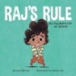 Raj’s Rule for the Bathroom at School |  |  |  | $20.00
 | 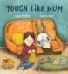 Tough Like Mum |  |  |  | $22.00
 | 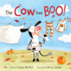 The Cow Said BOO! |  |  |  | $20.00
 | 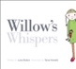 Willow’s Whispers (soft cover) |  |  |  | $15.00
 | 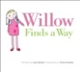 Willow Finds a Way (soft cover) |  |  |  | $15.00
 | 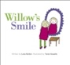 Willow’s Smile |  |  |  | $20.00
TOTAL (tax included)
Cash or cheque to Lana Button

